October 21, 2007 ~ Augusta, New Jersey
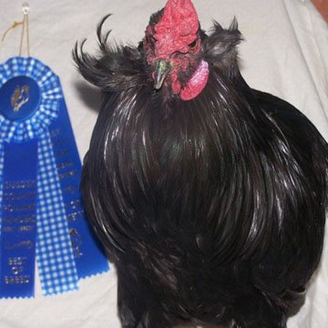 | Black Standard Cock  Best of Breed  Best of Variety  1st Place  'Jack'  October 21 ~ Augusta, New Jersey  Sussex County Poultry Association Fall Show  709 Entries  Exhibitor: Jean Blancato  West Milford, New Jersey

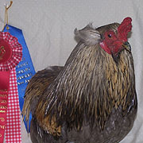  1st Place  Reserve of Breed  Reserve of Variety  Standard Cock (AOV)  "Pete"  Exhibitor: Jean Blancato  West Milford, New Jersey | 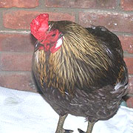  1st Place  Standard Cock (AOV)  "Mr Violet"  Exhibitor: Jean Blancato  West Milford, New Jersey | 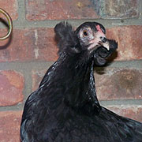  1st Place  Standard Black Pullet  "Marta"  Exhibitor: Jean Blancato  West Milford, New Jersey | 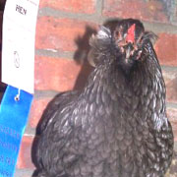  1st Place  Standard Blue Hen (AOV)  "Bluebell"  Exhibitor: Jean Blancato  West Milford, New Jersey

